**IT351: Human Computer Interaction**

**Lab Assignment 1**

**Serial Position Effect**

**Name:** Chinmayi C. Ramakrishna **Date of Submission:** 5th January, 2021

**Roll No.:** 181IT113

--------------------------------------------------------------------------------------------------------------------------------------------

The serial position effect is a tendency of the human mind to recollect the first and last items of a sequence/list more easily than the ones in the middle. It is one of the many [cognitive biases of the human mind](https://productiveclub.com/cognitive-biases/).

The effect is attributed to the human brain’s two other cognitive biases called the primacy effect and the recency effect.

### **Primacy effect:**

As per the primacy effect, the items at the beginning of a list are easy to remember because of how humans recall things from memory. Due to repetition, your mind becomes more familiar with the initial items.

### **Recency effect:**

As per the recency effect, you recall the last few items of the list because they are more recent and, therefore, fresh in your mind.

**Application:**

Serial Position Effect can be used to provide better User Interface experience.

**Serial Position Effect experiment:**

1. To test the serial position effect, a small experiment can be carried out.
2. It's a simple memory game of remembering 10 animals from a list.
3. A timer is set to 10 seconds to remember the animals. Then the user has to select the animals that he/she can recall from a list of 16 animals.
4. In the end an analysis is given of the experiment. To carry out this experiment, an electron app has been developed to provide a GUI.

**Screenshots of the GUI:**

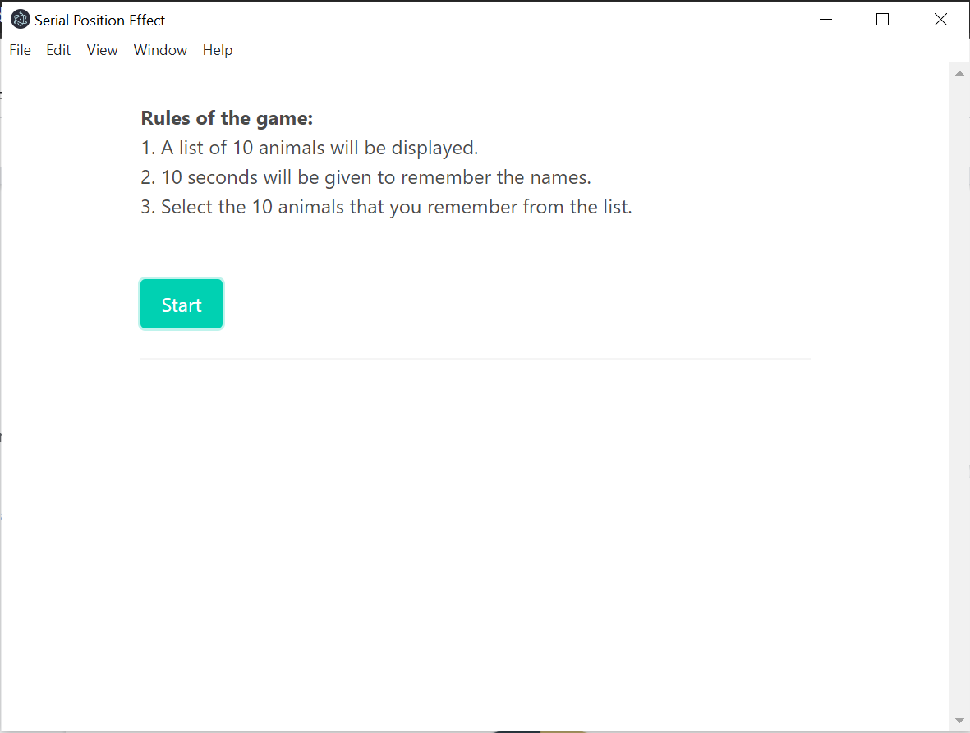

Fig 1. Home

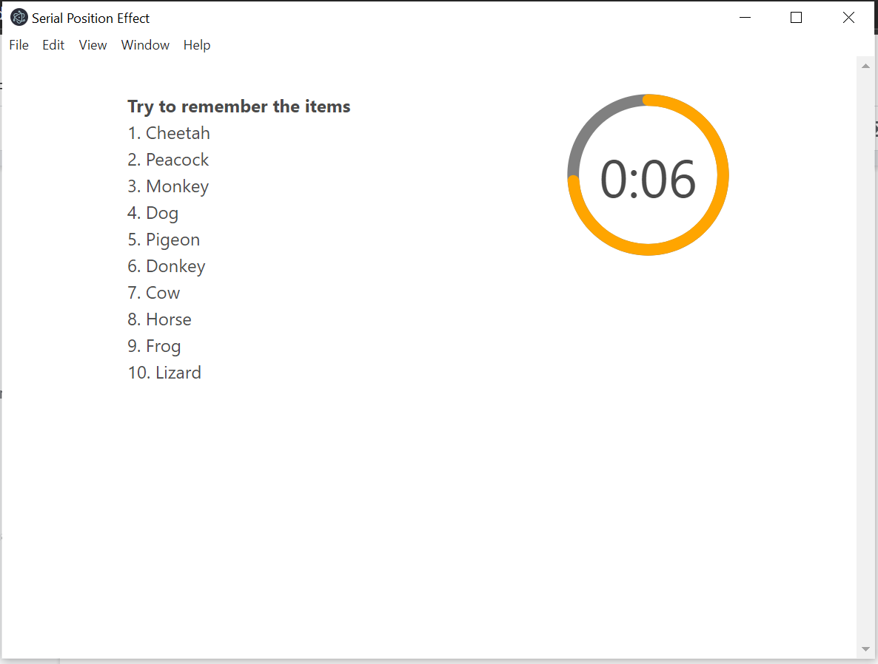

Fig 2. Timer

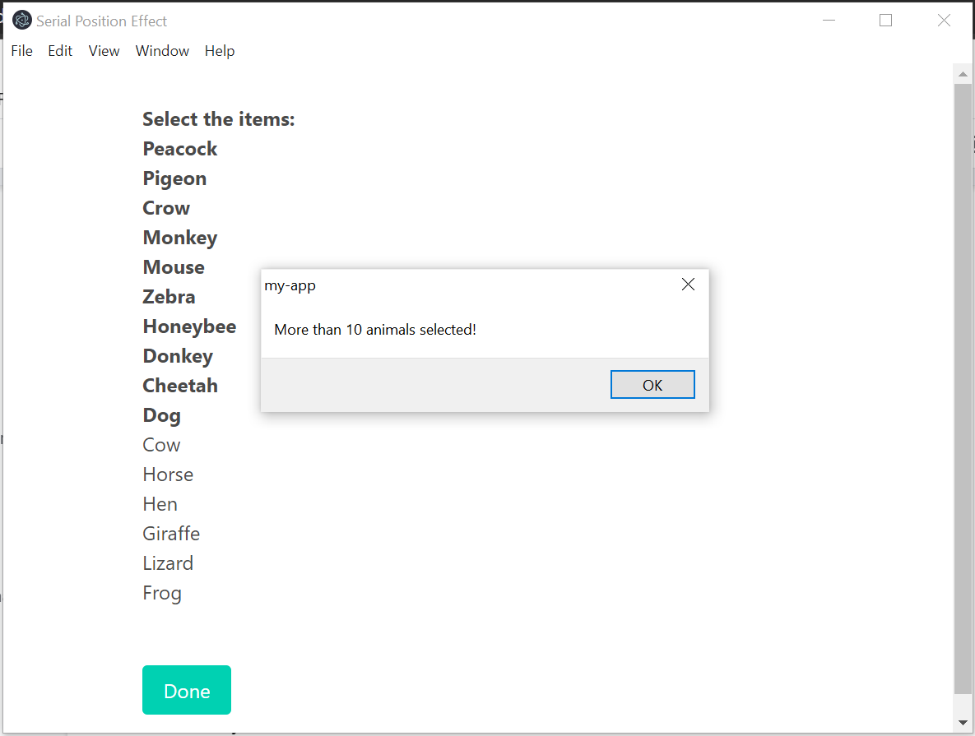

Fig 3. Select the recalled animals

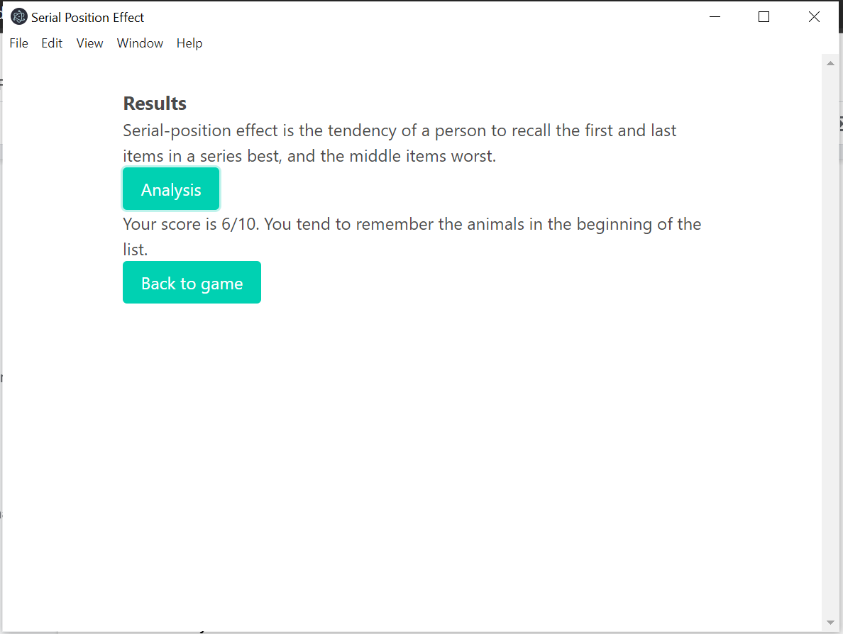

Fig 4. Results and Analysis

**Survey Details:**

1. Number of participants: 20
2. Number of animals: 10
3. List of animals:

* Cheetah
* Peacock
* Monkey
* Dog
* Pigeon
* Donkey
* Cow
* Horse
* Frog
* Lizard

1. List to select from:

* Peacock
* Pigeon
* Crow
* Monkey
* Mouse
* Zebra
* Honeybee
* Donkey
* Cheetah
* Dog
* Cow
* Horse
* Hen
* Giraffe
* Lizard
* Frog

1. Time given : 10 seconds

**Observations:**

Number of participants who guessed first 3 animals correctly: 18

Number of participants who guessed last 3 animals correctly: 17

Number of participants who guessed all correctly: 2

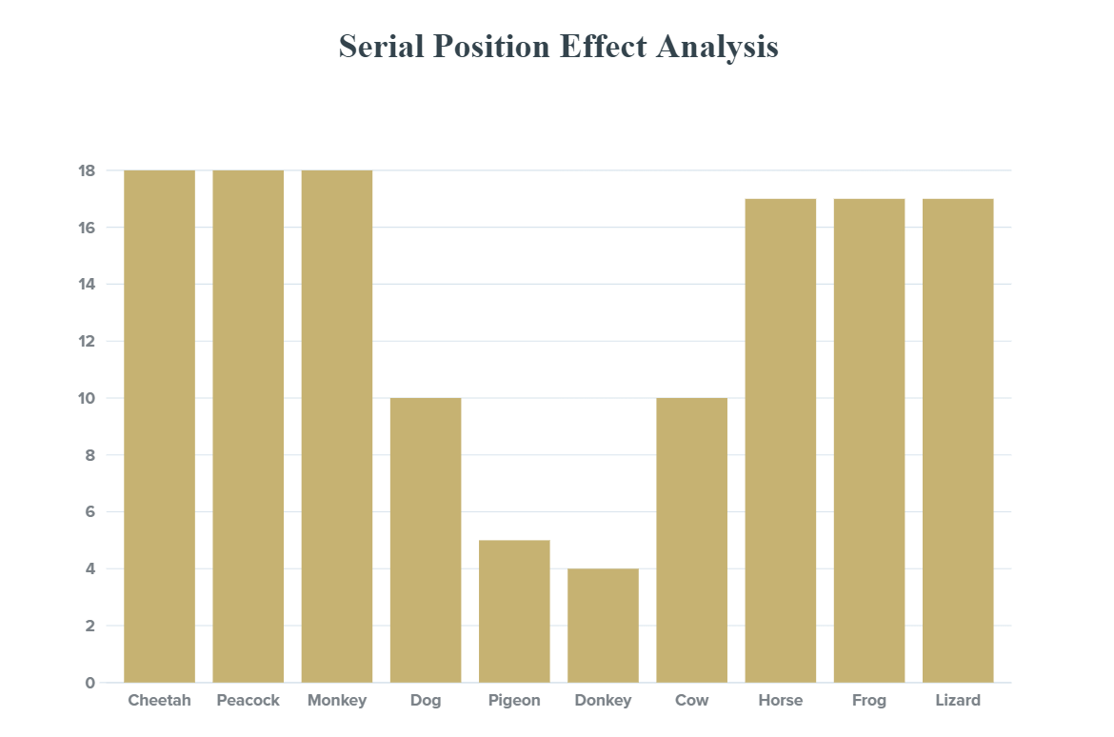

Fig 5. Number of participants vs Animals

**Percentage recall of each animal:**

|  |  |  |  |  |  |  |  |  |  |
| --- | --- | --- | --- | --- | --- | --- | --- | --- | --- |
| Cheetah | Peacock | Monkey | Dog | Pigeon | Donkey | Cow | Horse | Frog | Lizard |
| 90% | 90% | 90% | 50% | 25% | 20% | 50% | 85% | 85% | 85% |

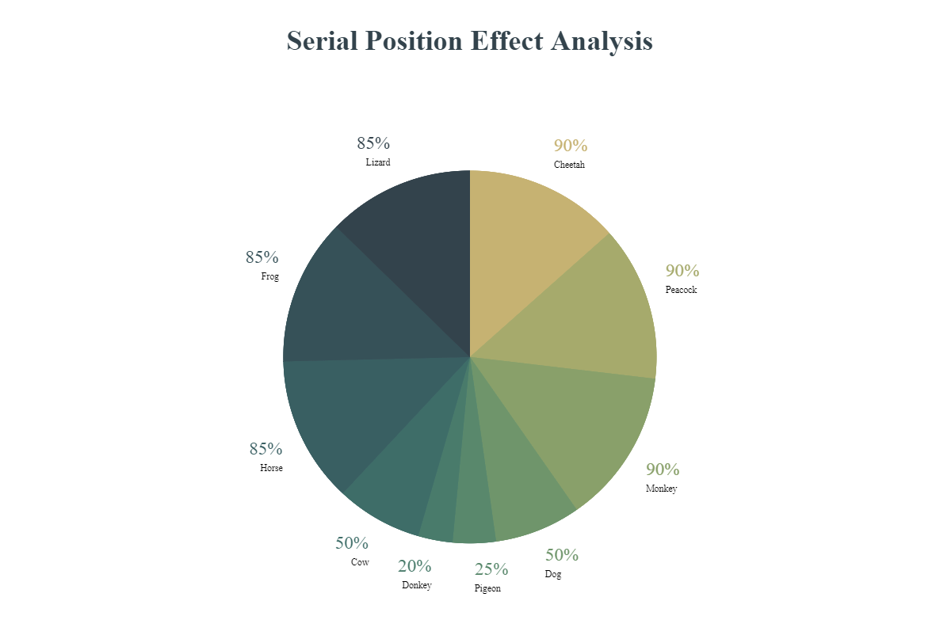

Fig 6. Pie chart representing animals and their percentage recall.

**Analysis:**

1. The animals in the beginning and end of the list have the highest recall percentage.
2. Some animals like dog and cow are remembered in spite of their position. This may be due to their popularity.
3. Some individuals recalled Pigeon as it was their favourite from the list.
4. On performing the experiment multiple times, it was observed that individuals tend to recall more animals from the list.
5. This experiment proves Serial Position Effect.